Primates, Hominin and Immunity Test. YEAR 12. 2015.

Name___________________________________. Mark= /

|  |  |  |
| --- | --- | --- |
| Test section | Possible mark | Your mark |
| Multiple choice | 20 |  |
| Short answer | 21 |  |
| Extended answer | 10 |  |
| Total | 51 |  |

***Multiple choice answer sheet.* Use a ball point or ink pen to mark an X** on the letter that represents the best answer from the choice of answers. Marks are not deducted for wrong answers.

|  |  |  |  |
| --- | --- | --- | --- |
| Question | Answer | Question |  |
| 1 | A B C D | 11 | A B C D |
| 2 | A B C D | 12 | A B C D |
| 3 | A B C D | 13 | A B C D |
| 4 | A B C D | 14 | A B C D |
| 5 | A B C D | 15 | A B C D |
| 6 | A B C D | 16 | A B C D |
| 7 | A B C D | 17 | A B C D |
| 8 | A B C D | 18 | A B C D |
| 9 | A B C D | 19 | A B C D |
| 10 | A B C D | 20 | A B C D |

Multiple Choice Section

1. Which of the following would contain the greatest number of species?
2. Kingdom
3. Phylum
4. Species
5. Genus

Look at the three skulls below. Use these drawing to answer questions 2, 3 and 4.

|  |  |  |
| --- | --- | --- |
| A | B | C |
| http://3.bp.blogspot.com/_vZtAOUAS7HQ/SDD6C3TtgHI/AAAAAAAAAIc/b-16E1IpaCk/s400/skull_study_profile-400.png | http://www.transientvisions.com/images/gorilla_skull.jpg | http://4.bp.blogspot.com/_prb792zvLfg/S7qyhS7Gt0I/AAAAAAAAAtg/QUdz7-X3dlU/s1600/Australopithecus.jpg |

1. Which skull shows most Prognation?
2. A
3. B
4. C
5. None of the skulls show Prognation.
6. Which skull has a diastema?
7. A and B
8. B only
9. A only
10. C only
11. Which skull/s are not hominin?
12. A
13. B
14. C
15. A and C
16. Which of the following matches the correct Hominin with the correct tool culture?
17. Oldowan and Homo sapiens
18. Oldowan and Homo habilis
19. Acheulian and Gorillas
20. Acheulian and Australopithecus.
21. Which of the following statements about the move to an agricultural lifestyle by Humans is **FALSE**?
22. Its long term affect was an increase in population numbers.
23. It caused people to move from hunter gathering lifestyles.
24. It is first seen with Homo erectus.
25. It is not seen in all parts of the world.
26. Which of the following lists the primates in order of evolution, going from simple to more complex.
27. Lemur, monkeys, apes and Humans.
28. New world monkeys, Old world monkeys and apes.
29. Old world monkeys, new world monkeys and lemurs.
30. Apes, Prosimians, monkeys and Humans.
31. Which of the following will have the largest olfactory center relative to total brain size?
32. New world Monkey
33. Old world Monkey
34. Homo erectus
35. Lemur
36. Which of the following is **not** true of Homo erectus?
37. It had a sloping forehead compared to Homo sapiens.
38. It was able to live in colder climates than Homo habilis.
39. It had a similar cranial capacity to Homo neanderthalensis.
40. It had pentadactyl hands.
41. Which one of the following changes is irrelevant in the evolution of humans?
42. An increase in convolutions of the cerebral cortex.
43. Precision grip.
44. Increased complexity of tool culture.
45. A move from grain to root vegetables in the diet.

Look at this diagram and use it to choose the correct answers for question 11.

[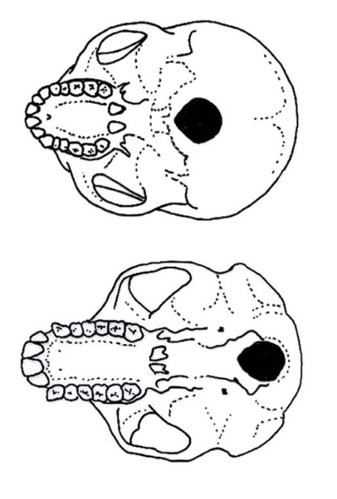](http://www.google.com.au/url?sa=i&rct=j&q=human+foramen+magnum+and+ape+foramen+magnum&source=images&cd=&cad=rja&docid=GZu10pa2Sq9xUM&tbnid=Z1eJ4IXbkGP6DM:&ved=0CAUQjRw&url=http://australianmuseum.net.au/image/Undersides-of-a-human-and-a-chimpanzee-skull&ei=okUyUoKYLMWFkAWA9YH4Bg&psig=AFQjCNHfHu1Y0VC_PCg78305teS8wfw0TA&ust=1379112690280839)

1. 1. The skull on the left is a bipedal primate with reduced prognation and a diastema.
   2. The skull on the left is a bipedal primate with large prognastion and a diastema.
   3. The skull on the right is a bipedal primate with a large prognation and no diastema.
   4. The skull on the right is a bipedal primate with reduced prognation and no diastema.

12. All of knowledge, technology, beliefs, roles, concepts of the universe, material objects and possessions seen in a group of people, is called the:

a. Culture.

b. Religion.

c. Society.

d. Heritage.

13. The antibodies that a baby receives from its mother are an example of:

1. Natural passive immunity.
2. Artificial passive immunity.
3. Natural active immunity.
4. Artificial active immunity.

Use the diagram below to answer questions 14 and 15.

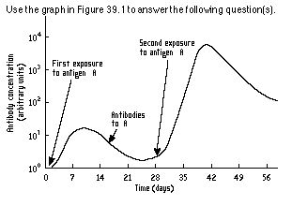

1. Why does the antibody concentration between 21 and 28 days **not** drop back to zero?
2. Memory T cells carry antibodies able to respond to antigen A.
3. Killer T cells carry antibodies able to respond to antigen A.
4. Memory B cells carry antibodies able to respond to antigen A.
5. Plasma B cells carry antibodies able to respond to antigen A.
6. The response to antigen A at 28 days would result in:
7. A rapid response and little or no symptoms of infection.
8. A reduction in T cells, but an increase in B cells.
9. Similar symptoms as seen in days 0 to 14.
10. A new set of antigens being produced.

16. Vaccination using attenuated antigens is an example of:

1. Natural passive immunity.
2. Artificial passive immunity.
3. Natural active immunity.
4. Artificial active immunity.
5. **B** lymphocytes are
6. made in the bones and mature in the bones. They produce antibodies and do antibody-mediated resistance.
7. are made in the bones and mature in the thymus gland. They perform cell-mediate resistance.
8. are made in the Pancreas and mature in the bones. They perform magic tricks.
9. are made in the bones and mature in the pituitary gland. They perform cell-mediate resistance.
10. **Antibodies:**
11. are proteins made in response to the leucocytes. They destroy, or in some other way neutralise red blood cells.
12. are proteins made in response to the antigens. They destroy, or in some other way neutralise antigens.
13. are proteins made in response to germ line mutations. They destroy, or in some other way neutralise mutations.
14. are proteins made in response to the antigens. They destroy, or in some other way neutralise digestive enzymes.
15. Look at the map below.

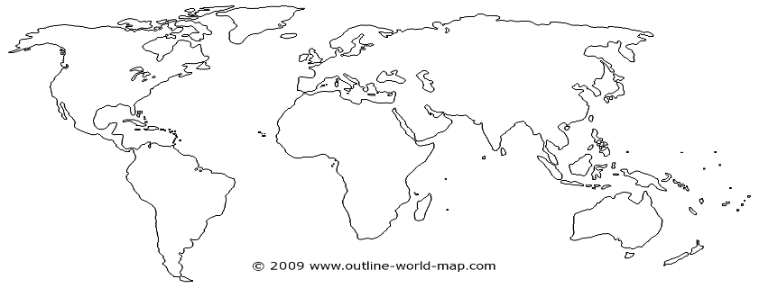

It shows the distribution of [Acheulean](http://en.wikipedia.org/wiki/Acheulean) tool finds. This distribution is probably due to:

1. The migration of Homo erectus.
2. The emergence of Homo sapiens.
3. The emergence of Australopithecus.
4. The migration of Homo neanderthalensis.
5. [Mousterian stone tools](http://en.wikipedia.org/wiki/Mousterian) discovered on the southern [Ionian Islands](http://en.wikipedia.org/wiki/Ionian_Islands) of Modern Greece, suggests that a species of Hominin was sailing the [Mediterranean Sea](http://en.wikipedia.org/wiki/Mediterranean_Sea) as early as 110,000 years BP. DNA of bone found at the same archeological site showed that the Hominin was not Homo sapien. What species was likely inhabiting this site?
6. Homo erectus.
7. Homo neanderthalensis.
8. Australopithecus afarensis.
9. Homo habilis.

Short Answer Section

1. Write definitions for all of the words in the table below

(2 marks)

|  |  |
| --- | --- |
| Term | Meaning |
| Arboreal |  |
| Bipedal |  |

1. The Sifaka and the Chimpanzee are both primates. What does this tell you about them?

(7 marks)

____________________________________________________________________________________________________________________________________________________________________________________________________________________________________________________________________________________________________________________________________________________________________________________________________________________________________________________________________________________________________________________________________________________________________________________________________________________________________________________________________________________________________________________________________________________________________________________________________________________________________________________________________________________________________________________________________________________________________________________________________________________________________________________________________________________________________________________________________________________________________

1. The use of fire caused major changes in lifestyle for hominins.
2. Which Hominin first used fire?

________________________________________________________________________

(1 mark)

1. What were the impacts of the use of fire?

________________________________________________________________________________________________________________________________________________________________________________________________________________________________________________________________________________________________________________________________________________________________________

1. marks)
2. The Cellular response to antigens is essential in an active response to antigens. Explain what initiates the cellular response and then explain the steps in this response. ____________________________________________________________________________________________________________________________________________________________________________________________________________________________________________________________________________________________________________________________________________________________________________________________________________________________________________________________________________________________________________________________________________________________________________________________________________________________________________________________________________________________________________________________________________________________________________________________________________________________________________________________________________________________________________________________________________________________________________________________________________________________________________________________________________________________________________________________________________________________________________________________________________________________________________________________________________________________________________________________________________________________________________________________________________________________________________________________________________________________________________________________________________________________________________________________________________________________________________________________________________________________________________________________________________________________________________________________________________________________________________________________________________________________________________________________________________________________________________________________________________________________________________________________________________________________________________________________________________________________________________________________________________________________________________________________________________________________

(7 marks)

Continued on the Next page

Extended Answer Questions

1. Lucy was the skeleton of an Australopithecus found in Africa. She was obviously a Hominin, but not a Homo sapien. List the skeletal characteristics that would indicate she was a Hominin. Also list the characteristics that separated her from the Homo sapiens.

(10 marks)

_______________________________________________________________________________________________________________________________________________________________________________________________________________________________________________________________________________________________________________________________________________________________________________________________________________________________________________________________________________________________________________________________________________________________________________________________

_______________________________________________________________________________________________________________________________________________________________________________________________________________________________________________________________________________________________________________________________________________________________________________________________________________________________________________________________________________________________________________________________________________________________________________________________

______________________________________________________________________________________________________________________________________________________________________________________________________________________________________________________________________________________________________________________________________________________________________________________________________________________________________________________________________________________________________________________________________________________________________________________________

______________________________________________________________________________________________________________________________________________________________________________________________________________________________________________________________________________________________________________________________________________________________________________________________________________________________________________________________________________________________________________________________________________________________________________________________

________________________________________________________________________________________________________________________________________________________________________________________________________________________________________________________________________________________________________________________________________________________________________________________________________________________________________________________________________________________________________________________________________________________________________________________________

**THE END**